

|  |  |  |
| --- | --- | --- |
|  | **Mathematics Department**  **11 Maths Methods Test 3 Odd**  **Trigonometry, Combinations, Transformation of Graphs and Circles.** | |
| **Name** |  |

**Section 1 – Resource Free**

**Marks : 30 Time: 30 minutes (maximum)**

**1. [2 marks]**

Use this unit circle below to estimate the value of sin 260° to 1 decimal place.



**2. [3 marks]**

Determine the value of the variable in each of the following:

a) sin 35°= sin A° where 90° < A < 360° A = ________

b) tan 75°= tan B° where 90° < B < 360° B = ________

c) cos 35°= sin C° where 90° < C < 360° C = ________

**3. [3 marks]**

Use Exact values to evaluate:

(sin 60°)(cos 210°) + (tan 135°)2

**4. [3 marks]**

Find the 10th term of the expansion of 

[you need to simplify your answer as much as possible]

**5. [3 marks]**

**Graph A** shown in bold below has equation .

Graphs B, C and D are all translations (no dilations) of graph A. Write down the equations of B, C and D



Graph B: ________________________

Graph C: ________________________

Graph D: ________________________

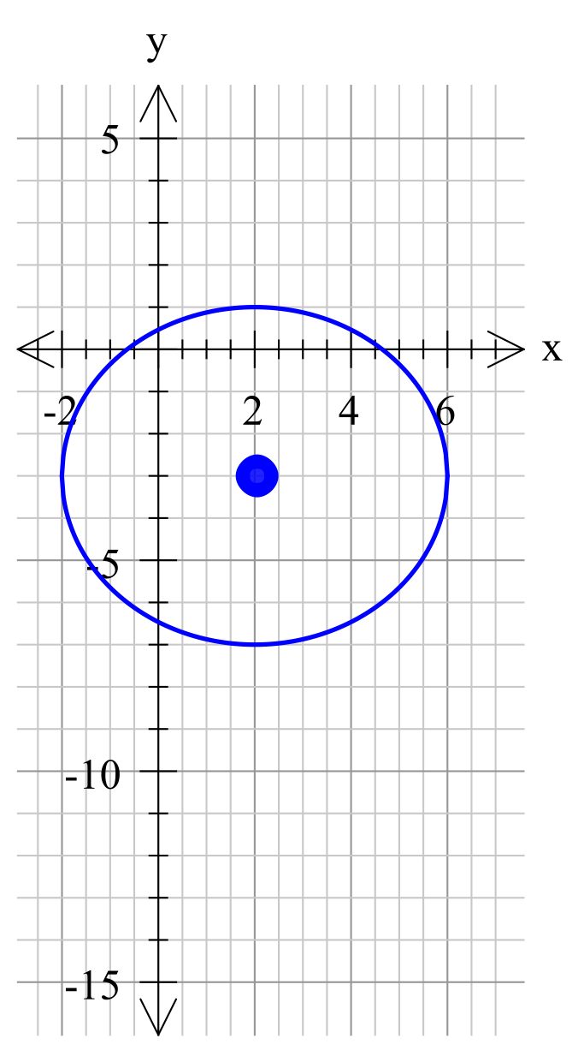**6. [8 marks]**

a) i) Find the equation of the circle drawn, you **do not** need to expand or simplify your answer.

ii) Give the domain and the range of this circle.

b) Find the centre and radius of the circle defined by:

x2 + y2 – 8x + 6y - 24 = 0

**7. [3 marks]**

Determine the equation of the graph below.

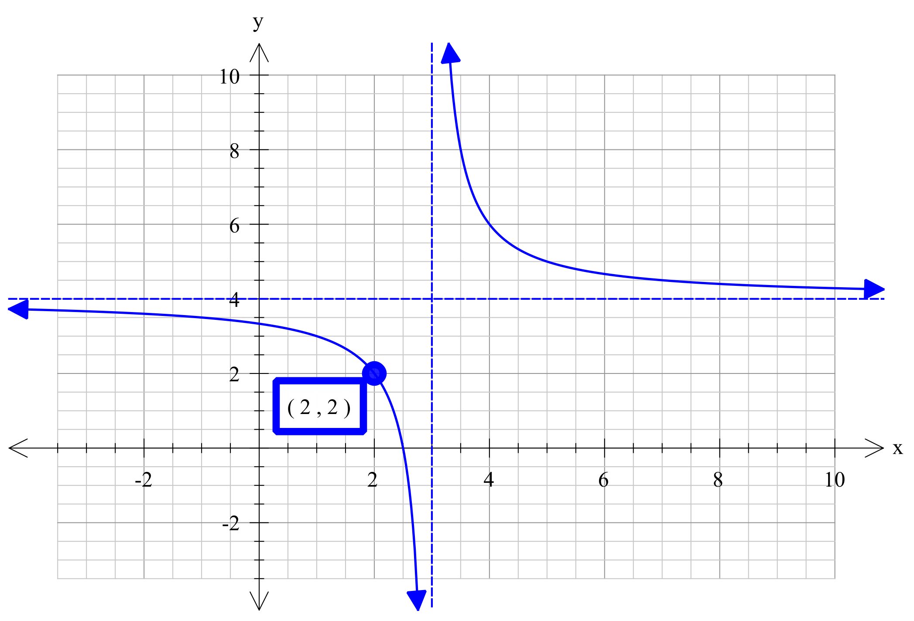

Equation:

**8. [5 marks]**

a) Describe the transformation that takes place when y = x3 is changed to,

y = 2(3x-4)3 + 5

b) The original graph contains the point (5, 125), where will this point be transformed to in the graph of y = 2(3x-4)3 + 5



|  |  |  |
| --- | --- | --- |
|  | **Mathematics Department**  **11 Maths Methods Test 1 Odd**  **Trigonometry, Combinations, Transformation of Graphs and Circles.** | |
| **Name** |  |

**Section 2 – Resource Rich**

**Marks : 29 Time: 30 minutes (minimum)**

**9. [2, 2 = 4 marks]**

A farmer has a paddock and he decides to fence off the corner PQR as shown in the diagram.



If PQ and QR are already fenced and are 22 metres and 18 metres respectively, find:

1. the length of PR still to be fenced (accurate to nearest centimetre).

b) the area of the enclosed paddock PQR .

**10. [5 marks]**

X, Y and Z are three points that all lie in a straight line with Y between X and Z.

The distance from X to Y is 50 metres.

A vertical tower, ZW, has its base at Z. The angle of elevation to the top of the tower at X is 30° and from Y is 50°.

Find the height of the tower.

**11. [8 marks; 1, 1, 2, 2, 2]**

Fourteen girls and seven boys are applying for five student council positions. Determine how many ways the council positions can be filled if:

a) there are no restrictions

b) three girls and two boys are selected

c) at least four girls are selected

d) at least one girl and one boy are selected.

e) there needs to be more boys than girls on the council.

**12. [6 marks]**

The electrical resistance of a wire varies directly to its length and inversely to the square of its diameter. The resistance of 500cm of wire, with a diameter of 0.5 mm is 20 ohms.

a) If the wire is increase to 800cm long, but the diameter stays at 0.5mm, what will be the new resistance?

b) If the diameter changes to 0.7mm, but the length stays at 500cm, what will be the resistance?

c) Find the resistance of 100cm of similar wire which has a diameter of 0.4mm.

**13. [1, 2, 3 = 6 marks]**

In triangle ABC the size of angle ABC is 30°, the side length of AB = 3x + 2 and

BC = 7x - 4.

a) Write an expression for the area of the triangle in terms of x.

[You do not need to simplify your expression]

b) Write an expression for the length of AC in terms of x.

c) Given that the area of the triangle is 131.75, find the value of x.